AZURE DATA ENGINEERING
BOOTCAMP PROJECT - 2

STUDENT NAME: DASARI PRAVEEN
PROGRAM: AZURE DATA ENGINEERING

PROJECT BRIEF

Databricks Project

We should bring data from on premises SQL server to ADLS Gen2 using ADF and from there we used Databricks for transforming data and load data into silver layer and finally into the gold layer. The preference of Databricks is because we have huge amount of data in our project.
This project outlines the end-to-end implementation of a modern data pipeline using

Azure Data Lake Storage Gen2, Databricks, and Power BI. The goal is to extract raw banking-related data files from a source location, clean and transform the data using PySpark in Databricks, apply Slowly Changing Dimensions (SCD) Type 1 for managing dimensional data, and finally visualize insights using Power BI.
The process follows a structured multi-layered architecture:

- Bronze Layer for raw data ingestion,
- Silver Layer for cleaned and transformed data, and
- Gold Layer for final curated data in Delta format.

Dynamic parameters and Azure Key Vault integration ensure secure, scalable, and configurable pipelines. The deliverables include detailed documentation, code snippets, and an architecture diagram to illustrate the workflow clearly.

Step 1: Get data from ADLS Gen2 to Databricks, using any one method. This connectivity has to be in a separate Notebook. This notebook has to be called in the transformation notebook.
- SAS Key method
- Account key method (access keys)
- Service principal method

Step 2: Transformations like Null checks, Date validations, creating a new column – Time Stamp column, duplicate checks, removing unnecessary columns and renaming columns. 5 tables = 5 notebooks or 1 notebook for data cleaning. All the tables have to be data cleaned and checks have to be done. The output should be saved in Delta Table (with a concept of cluster by) inside the data bricks, which are managed tables. [Silver Layer]

Step 3: Create SCD Type 1 for the notebook, for the notebook created in step 2, for any one table. Output should be stored in a delta table. [Gold layer]

‘
ARCHITECTURE DIAGRAM:

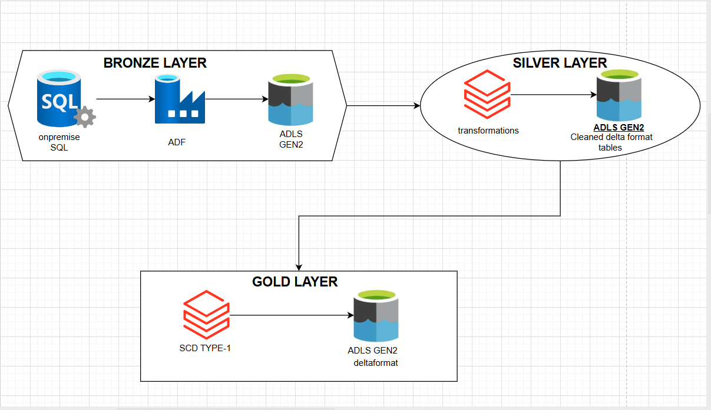

Task -1

Bronze Layer : Raw data ingestion, (Onpremise to ADLS GEN2)

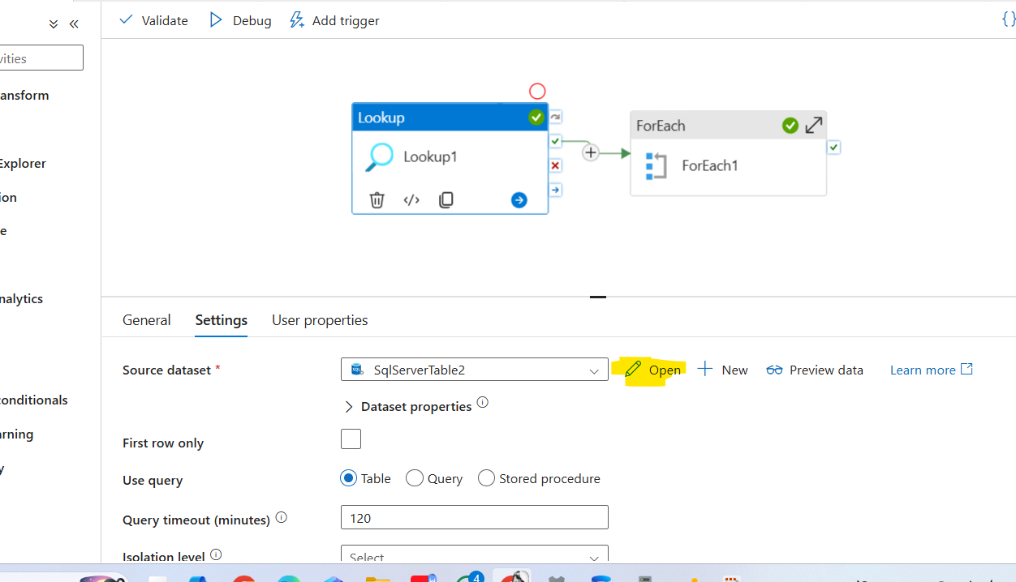

- Create a onpremise SQL server with the self integration runtime (its helps the adf connect to the SSMS to onpremise)
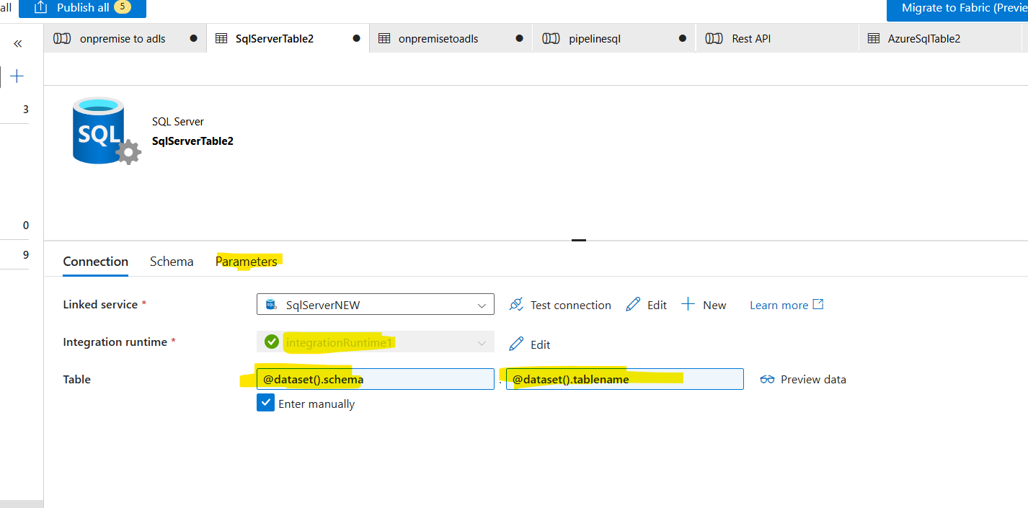
- Create the parameters of table name and schemaname
- Give table schema and tablename dynamically
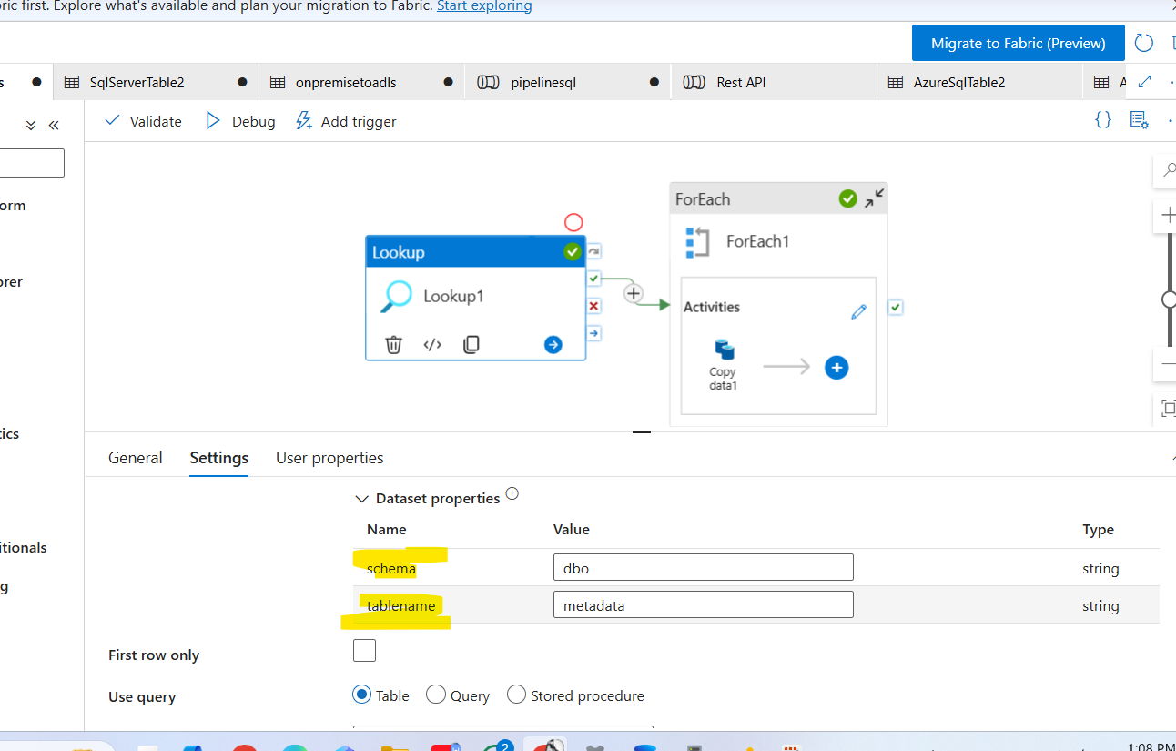
- Go back to the settings and give schemaname as DBO and tablename as Metadata in lookup

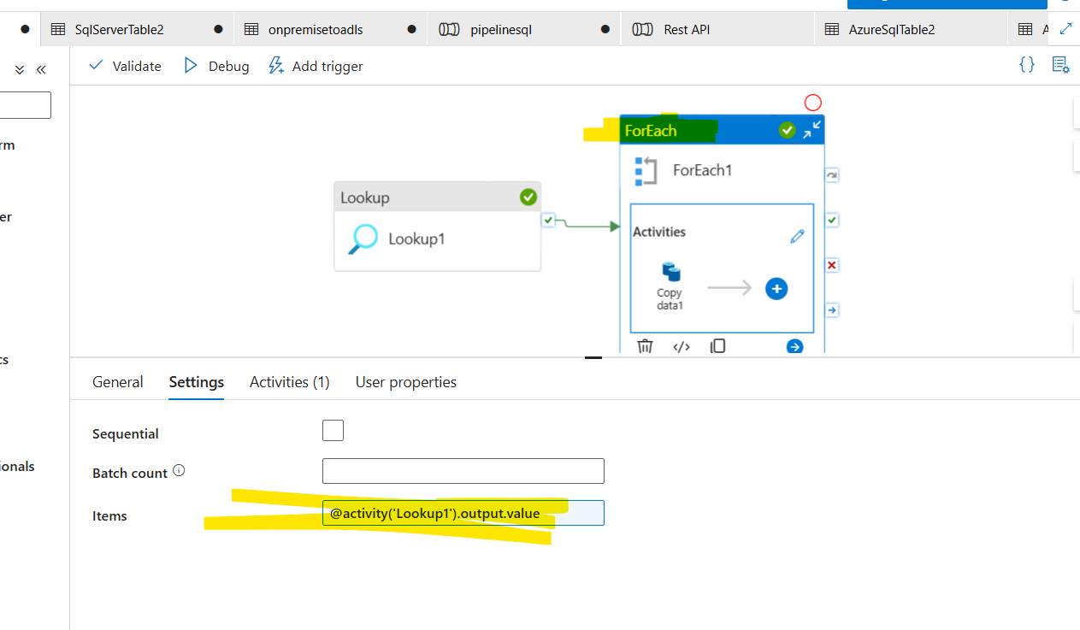

- Create a foreach activity and give connection from lookup to foreach
- In for each settings give items dynamically

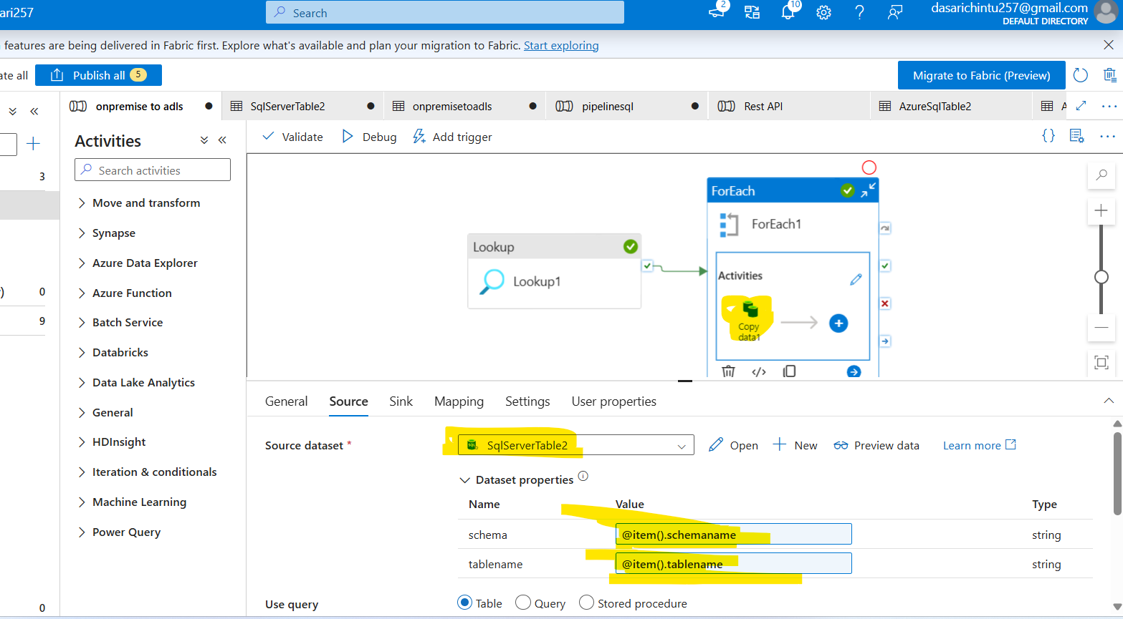
- Create a copy data inside the foreach
- And give source dataset onpremise SQL (which we given in look up)
- Give schemaname and tablename dynamically
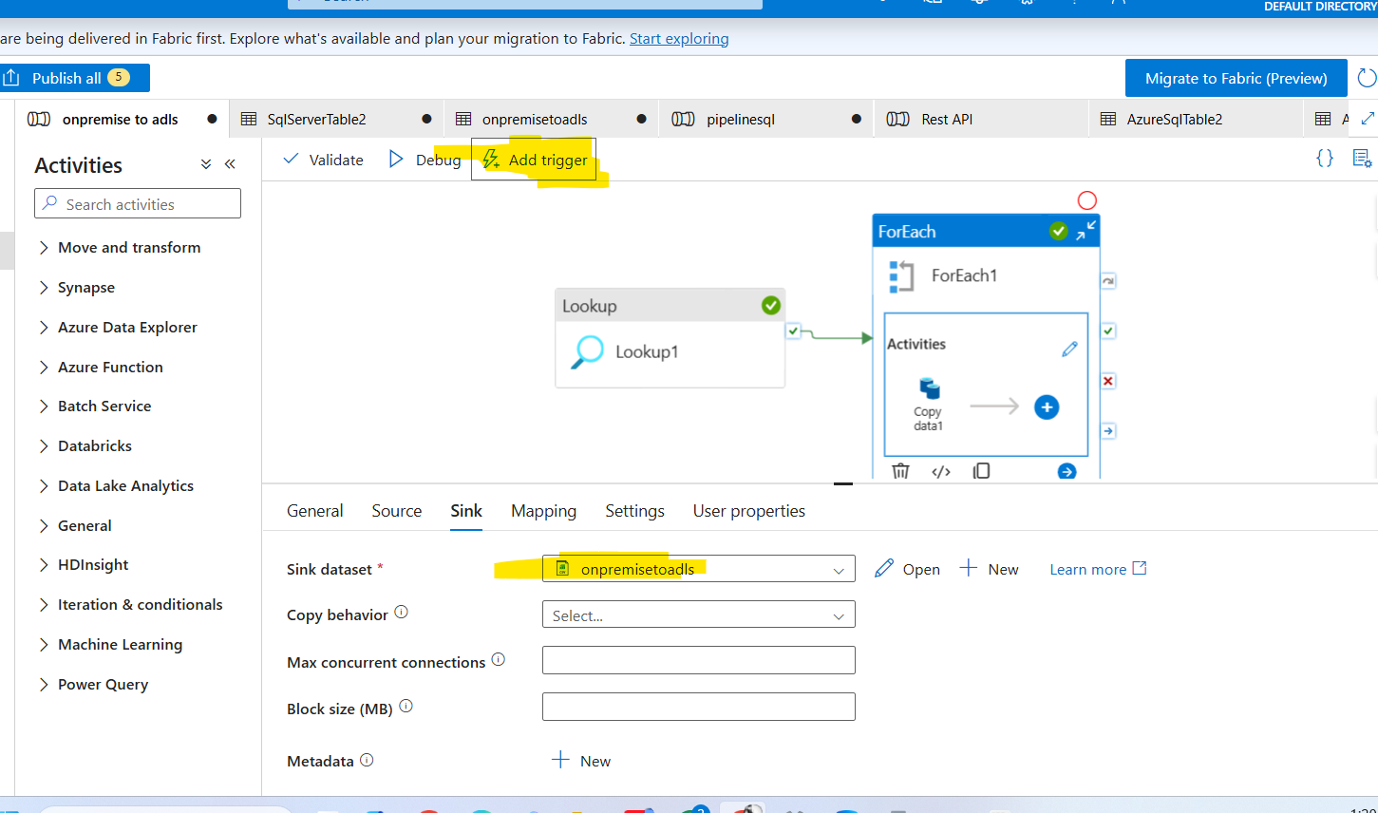
- Go to sink and create a sinkdata set and give path (we need to choose the format like csv, parquet)
- Add trigger (if required ) And debug the pipeline
- The data will be stored a ADLS Gen2 in given format
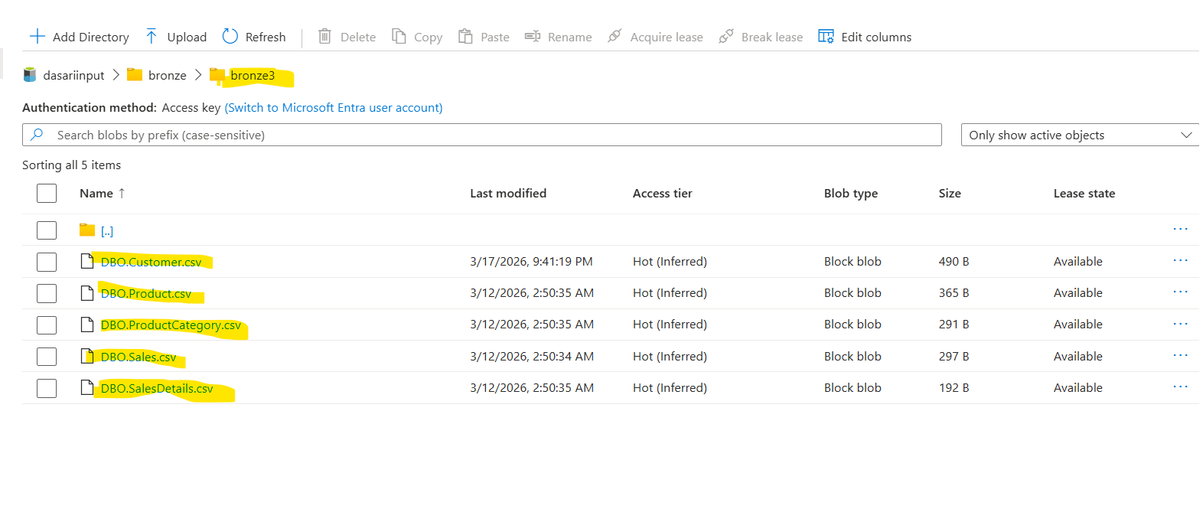
- The tables will be saved in adls gen2 in bronze folder

TASK-2:

Transformations like Null checks, Date validations, creating a new column – Time Stamp column, duplicate checks, removing unnecessary columns and renaming columns. 5 tables = 5 notebooks or 1 notebook for data cleaning. All the tables have to be data cleaned and checks have to be done. The output should be saved in Delta Table (with a concept of cluster by) inside the data bricks, which are managed tables. [Silver Layer]

Customer Notebook:

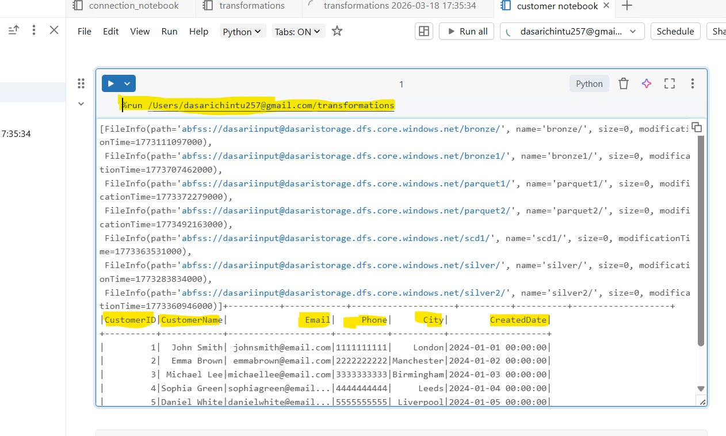

- %run is a magic command it will take the one notebookn data to another notebook

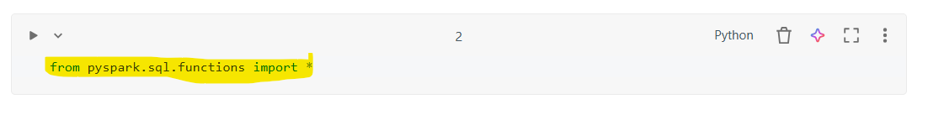
- This statement imports all built-in Spark SQL functions so you can use them directly in your PySpark code
- pyspark.sql.functions → module that contains many Spark SQL functions
- * → imports all functions from that module

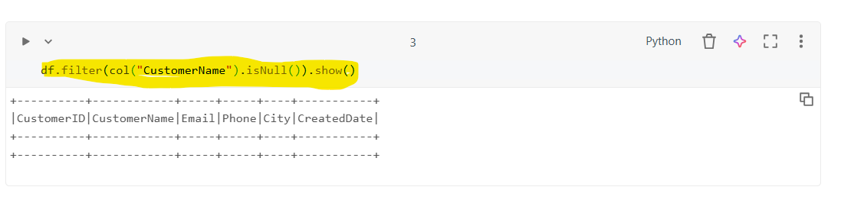
- df.filter(col("CustomerID").isNull()).show()
- filters the DataFrame and displays rows where the CustomerID column contains NULL values.

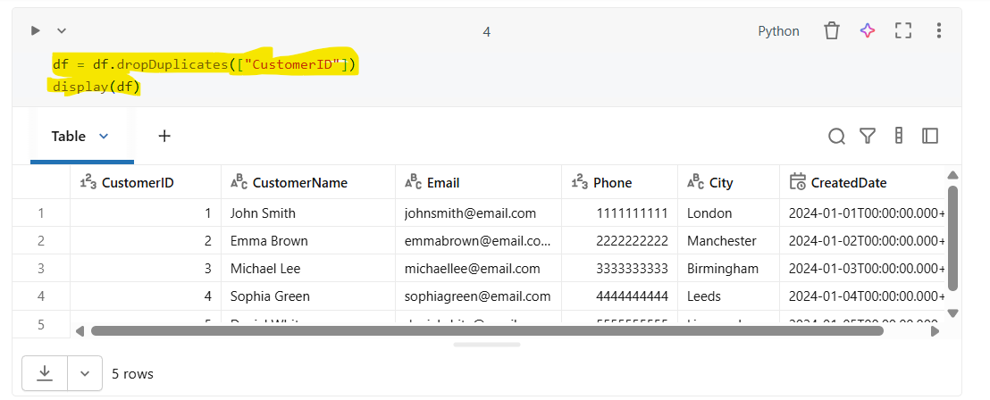

dropDuplicates()
- Used to remove duplicate records from a Spark DataFrame based on one or more columns.

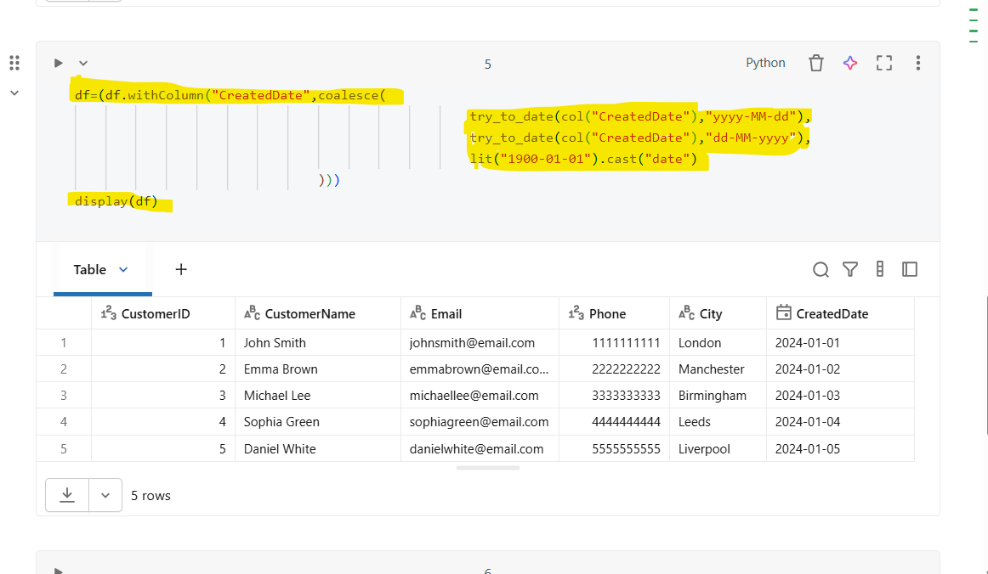

- withColumn() is used to create a new column or replace an existing column.

- Here it replaces the existing CreatedDate column with a cleaned date value.

- try_to_date() attempts to convert a string into a date format.

- If conversion fails, it returns NULL instead of throwing an error.

- coalesce() returns the first non-NULL value from the list.

- lit() creates a constant value.
This acts as a default fallback date when parsing fails.

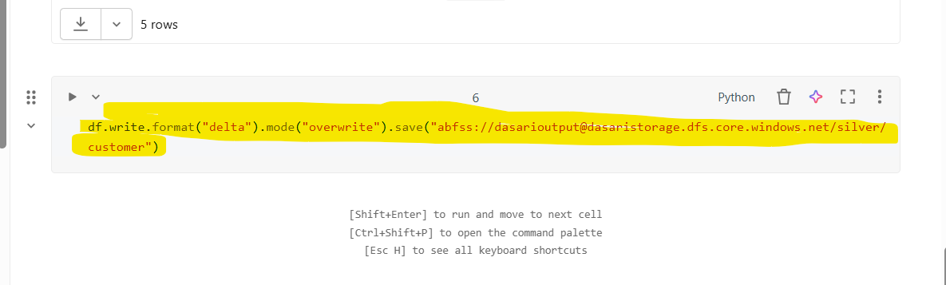

- It will be save in a delta format in a adls gen2

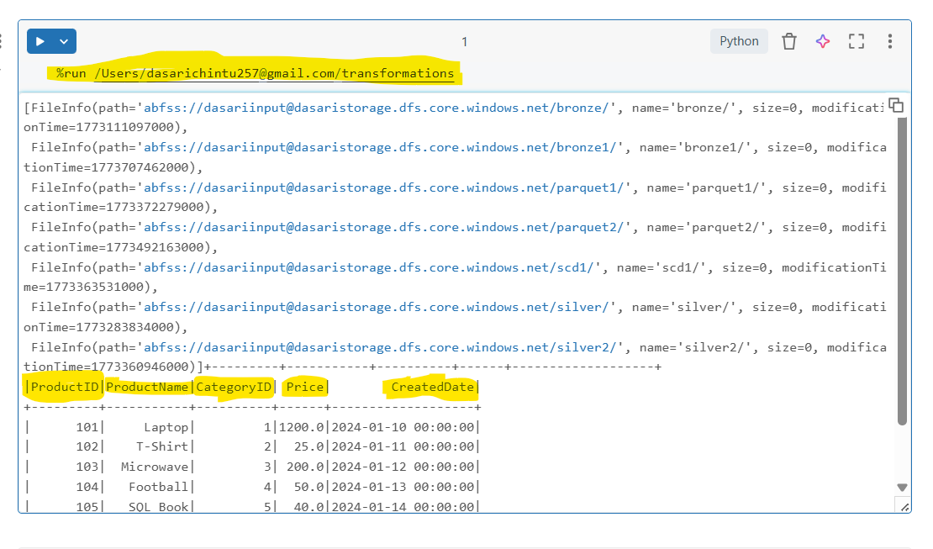

- %run is a magic command it will take the one notebookn data to another notebook


- This statement imports all built-in Spark SQL functions so you can use them directly in your PySpark code

- pyspark.sql.functions → module that contains many Spark SQL functions

- * → imports all functions from that module

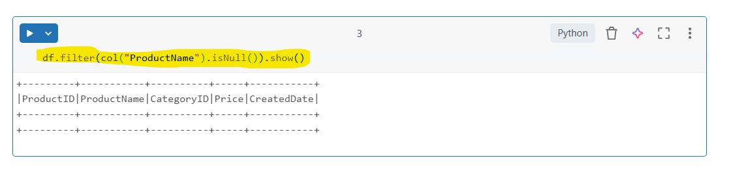

- df.filter(col("ProductID").isNull()).show()
- filters the DataFrame and displays rows where the ProductID column contains NULL values.

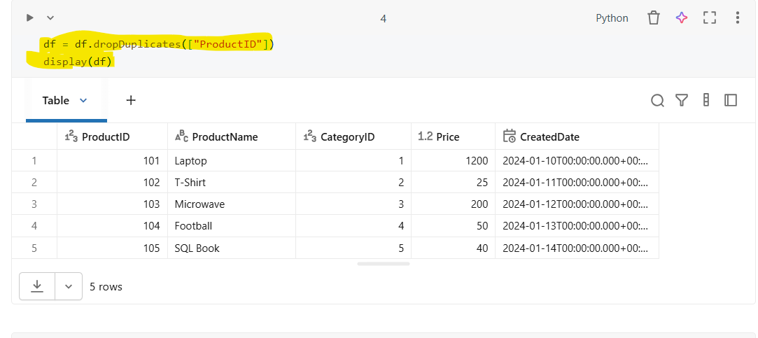

dropDuplicates()
- Used to remove duplicate records from a Spark DataFrame based on one or more columns.

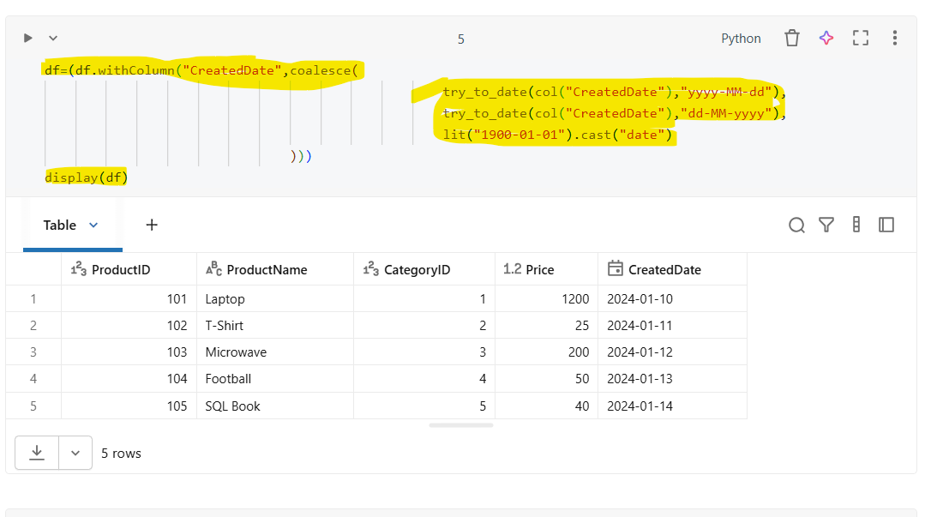
- withColumn() is used to create a new column or replace an existing column.

- Here it replaces the existing CreatedDate column with a cleaned date value.

- try_to_date() attempts to convert a string into a date format.

- If conversion fails, it returns NULL instead of throwing an error.

- coalesce() returns the first non-NULL value from the list.

- lit() creates a constant value.
- This acts as a default fallback date when parsing fails.

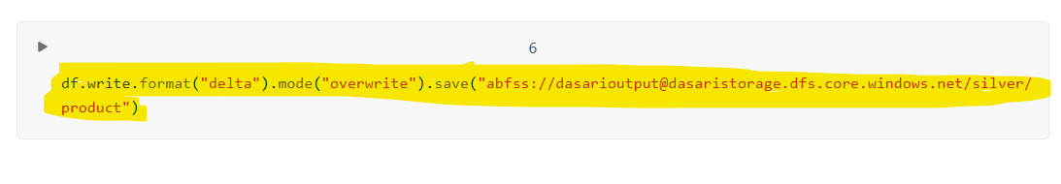
- It will be save in a delta format in a adls gen2

Category Notebook:
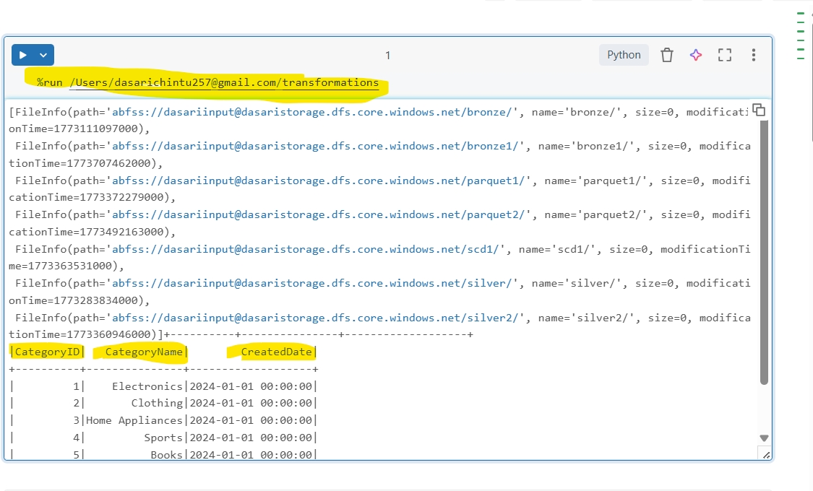
- %run is a magic command it will take the one notebookn data to another notebook


- This statement imports all built-in Spark SQL functions so you can use them directly in your PySpark code
- pyspark.sql.functions → module that contains many Spark SQL functions
- * → imports all functions from that module

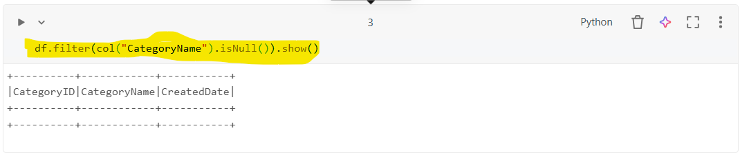

- df.filter(col("CategoryID").isNull()).show()
- filters the DataFrame and displays rows where the CategoryID column contains NULL values.

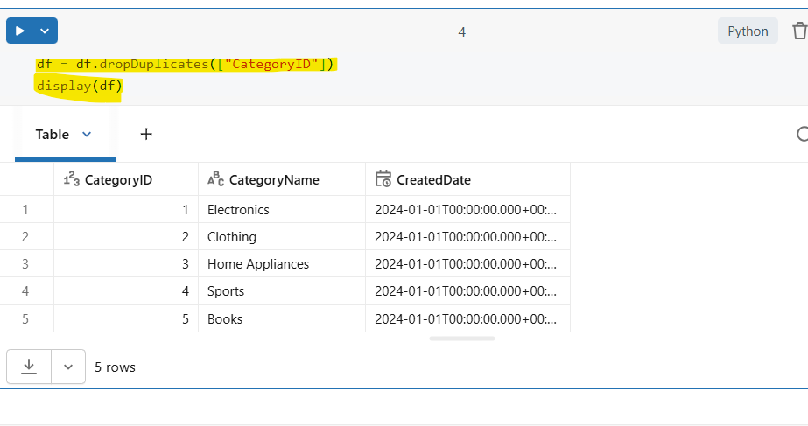
dropDuplicates()
- Used to remove duplicate records from a Spark DataFrame based on one or more columns.

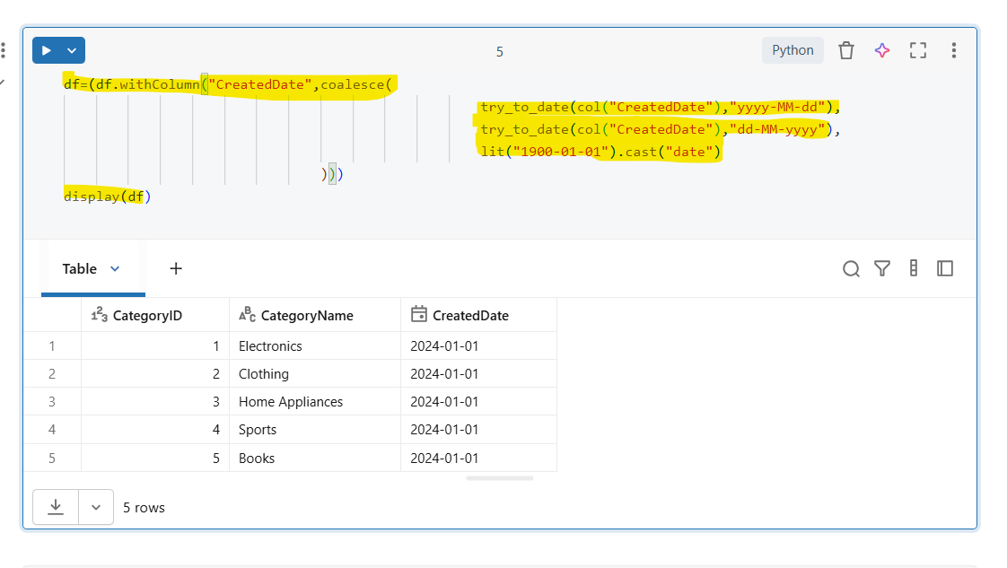

- withColumn() is used to create a new column or replace an existing column.

- Here it replaces the existing CreatedDate column with a cleaned date value.

- try_to_date() attempts to convert a string into a date format.

- If conversion fails, it returns NULL instead of throwing an error.

- coalesce() returns the first non-NULL value from the list.

- lit() creates a constant value.
This acts as a default fallback date when parsing fails.

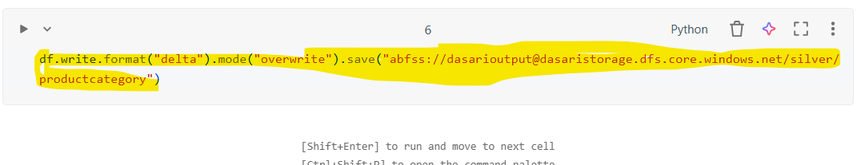

- It will be save in a delta format in a adls gen2

Sales Notebook

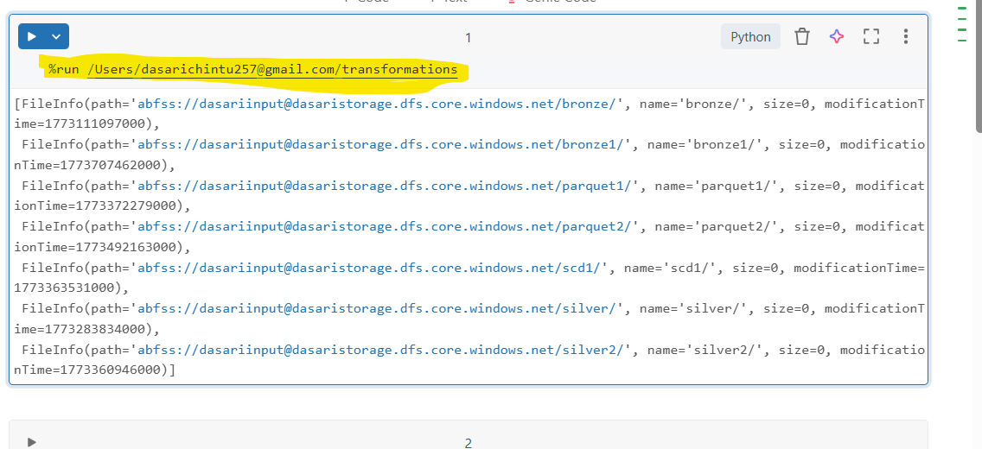
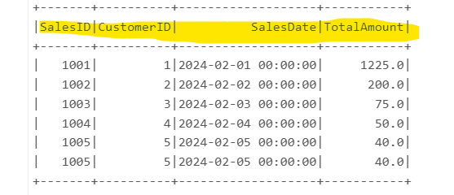
➢%run is a magic command it will take the one notebookn data to another notebook


- This statement imports all built-in Spark SQL functions so you can use them directly in your PySpark code
- pyspark.sql.functions → module that contains many Spark SQL functions
- * → imports all functions from that module

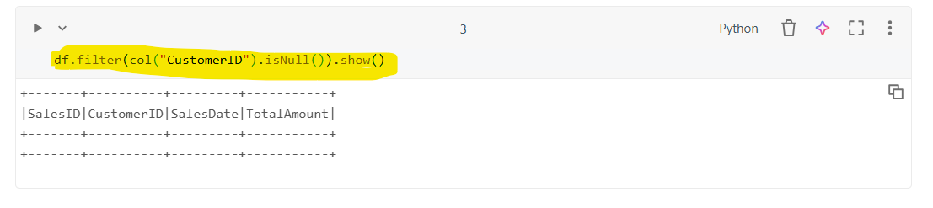
- ➢df.filter(col("ProductID").isNull()).show()
- ➢filters the DataFrame and displays rows where the ProductID column contains NULL values.
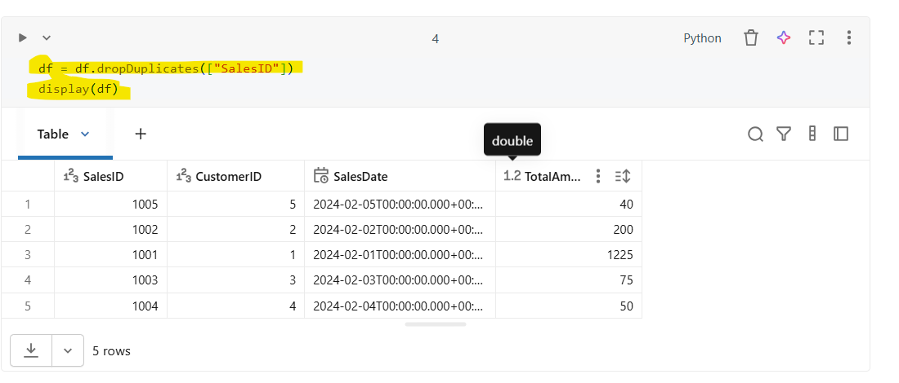
- ➢df.filter(col("CustomerID").isNull()).show()
- ➢filters the DataFrame and displays rows where the CustomerID column contains NULL values.

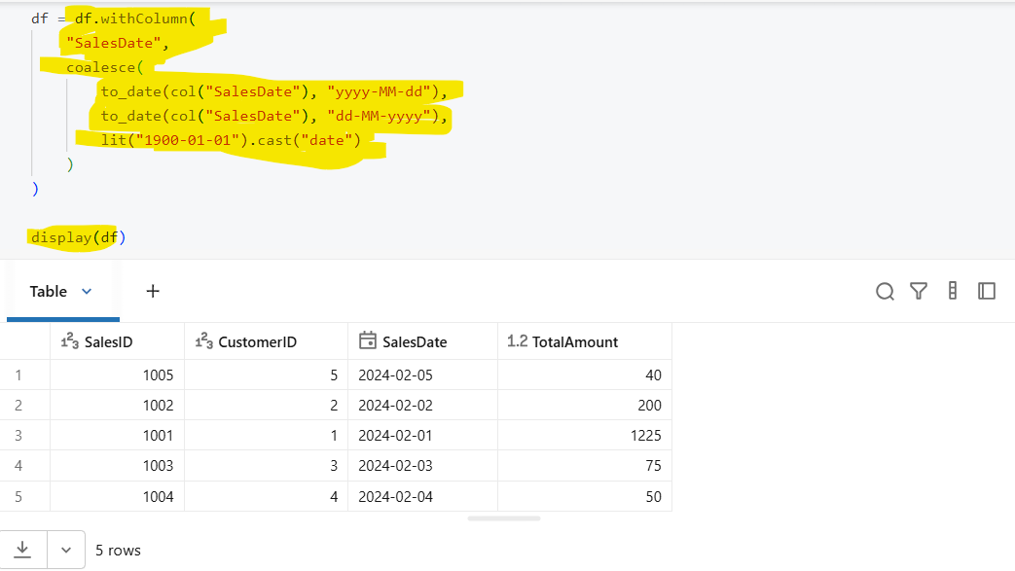
- ➢withColumn() is used to create a new column or replace an existing column.

- ➢Here it replaces the existing CreatedDate column with a cleaned date value.

- ➢try_to_date() attempts to convert a string into a date format.

- ➢If conversion fails, it returns NULL instead of throwing an error.

- ➢coalesce() returns the first non-NULL value from the list.

- ➢lit() creates a constant value.
This acts as a default fallback date when parsing fails.

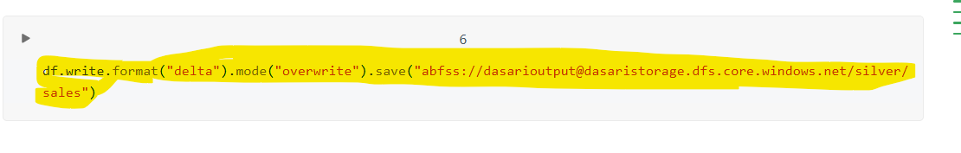

- ➢It will be save in a delta format in a adls gen2

Salesdetails notebook

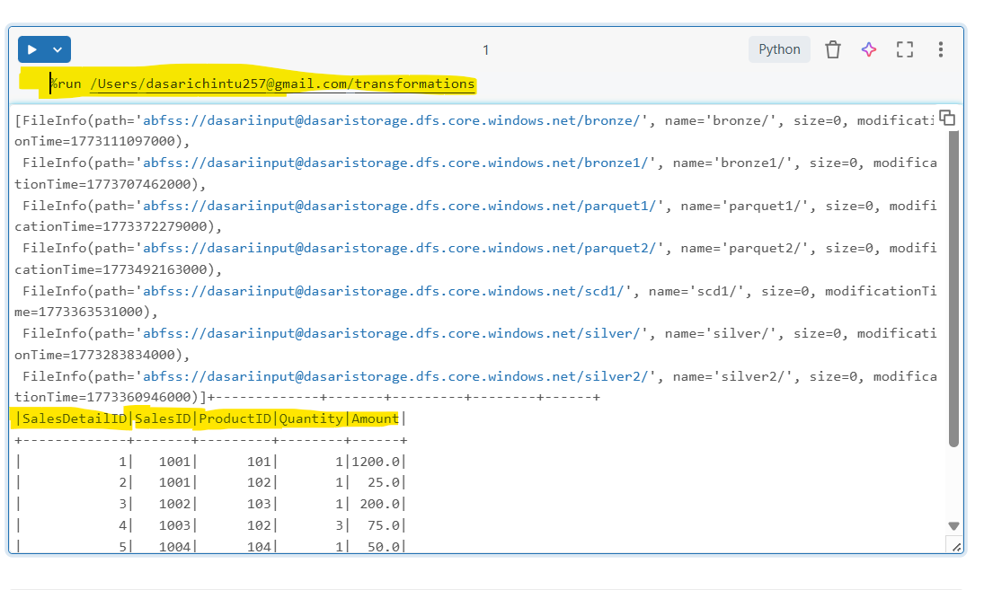

- %run is a magic command it will take the one notebookn data to another notebook


- ➢This statement imports all built-in Spark SQL functions so you can use them directly in your PySpark code
- ➢pyspark.sql.functions → module that contains many Spark SQL functions
- ➢* → imports all functions from that module

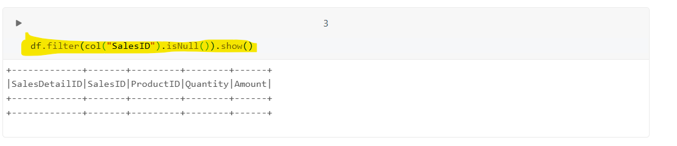

- ➢df.filter(col("SalesID").isNull()).show()
- ➢filters the DataFrame and displays rows where the SalesID column contains NULL values.

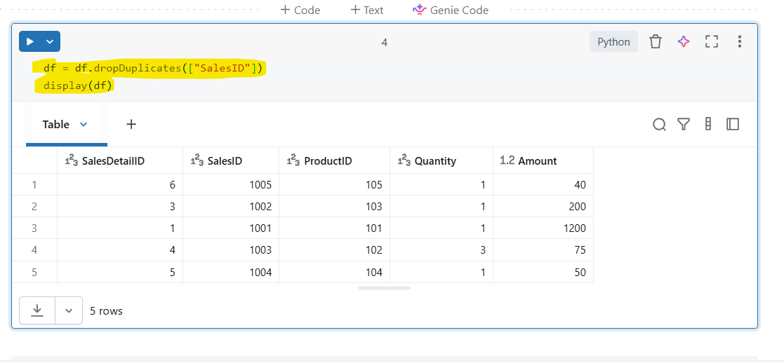

- dropDuplicates()
- ➢Used to remove duplicate records from a Spark DataFrame based on one or more columns.

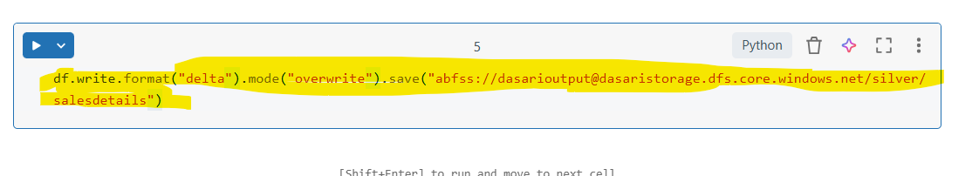

- ➢It will be save in a delta format in a adls gen2

Task-3 SCD TYPE-1

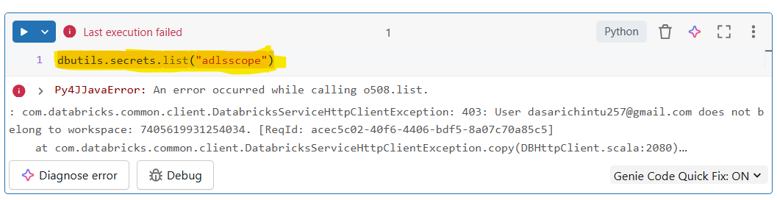

- dbutils.secrets.list(scope) is a Databricks utility command used to list all secret keys stored within a specified secret scope.

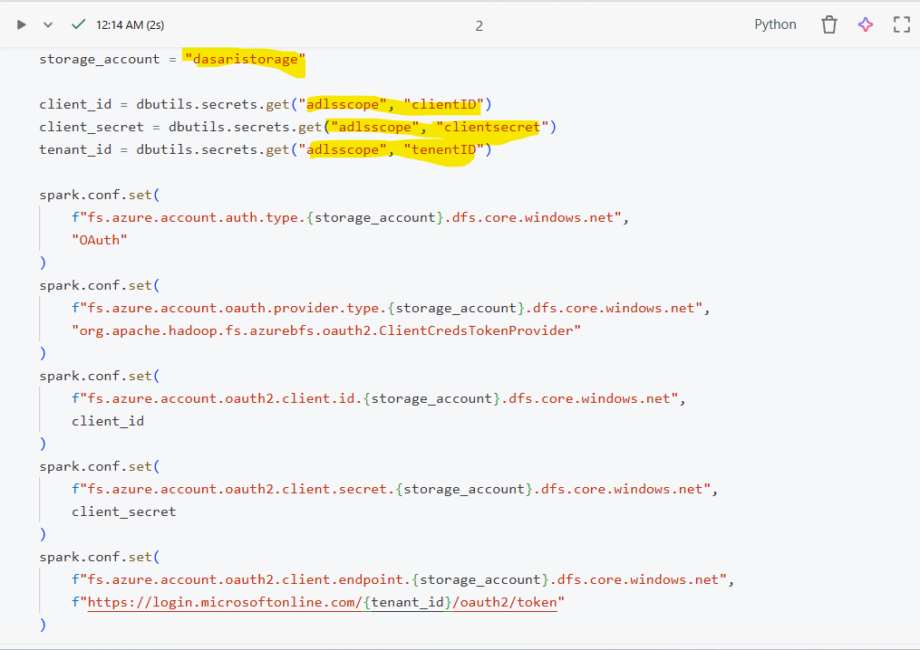

- This code configures secure access from Databricks to Azure Data Lake Storage Gen2 (ADLS Gen2) using a Service Principal with OAuth 2.0 authentication.
Sensitive credentials are retrieved securely from Databricks Secret Scope instead of hardcoding.
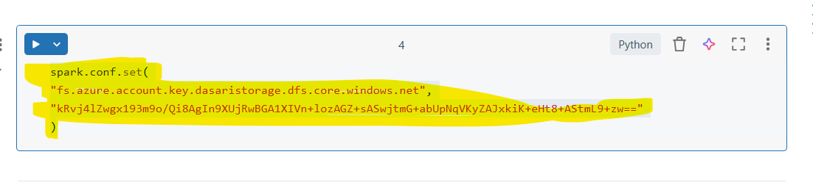
- This configuration enables Databricks (or Spark) to access Azure Data Lake Storage Gen2 (ADLS Gen2) using a Storage Account Access Key.
- It is a key-based authentication method, where full access to the storage account is granted using a secret key.

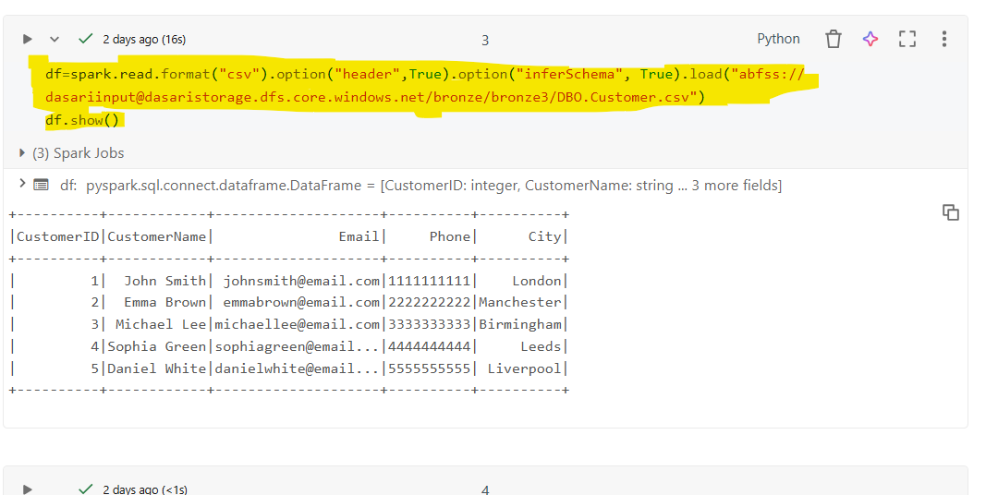

- This command is used in Databricks to list all files and folders available in a specified Azure Data Lake Storage Gen2 (ADLS Gen2) container path.

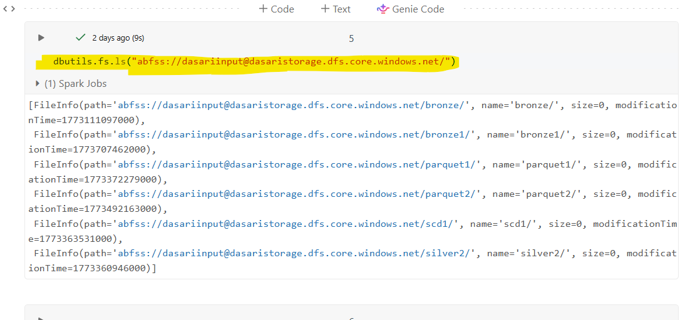
- Lists all files and directories in the specified Azure Data Lake Storage Gen2 (ADLS Gen2) path from a Databricks notebook.

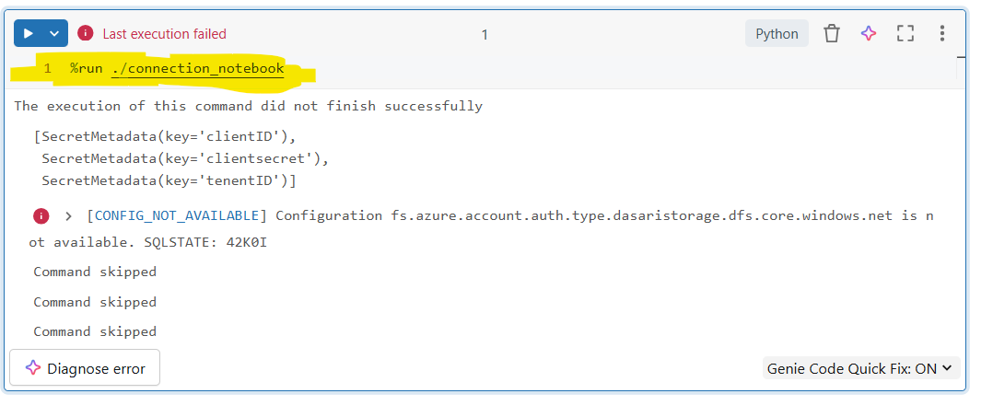
- %run is a Databricks magic command used to execute another notebook within the current notebook.
It allows you to reuse code such as configurations, functions, or connection setup

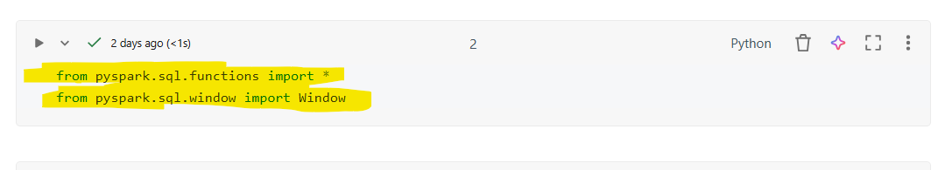

- These statements import built-in PySpark functions and windowing capabilities used for data transformation and analytical operations in Spark DataFrames.

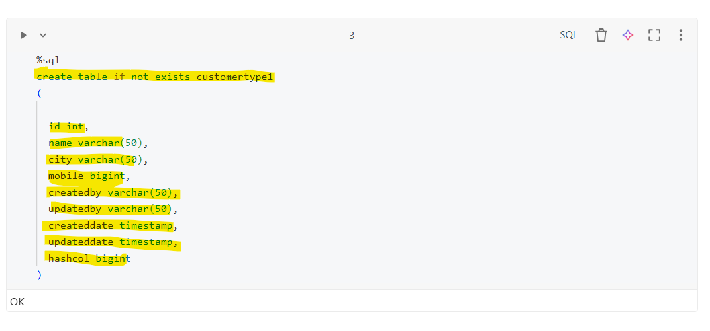

- This command creates a table in Databricks (or Spark SQL) to store in table using SCD Type 1 methodology.
- The table stores latest customer records only
- Existing records are overwritten when changes occur
- No historical tracking is maintained
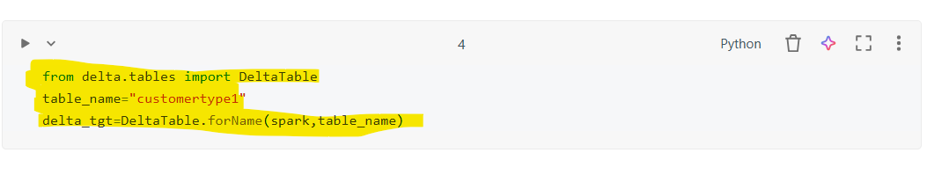
- This code is used to reference an existing Delta table in Databricks using the Delta Lake API.
It allows you to perform operations like MERGE (upsert), UPDATE, DELETE, and more
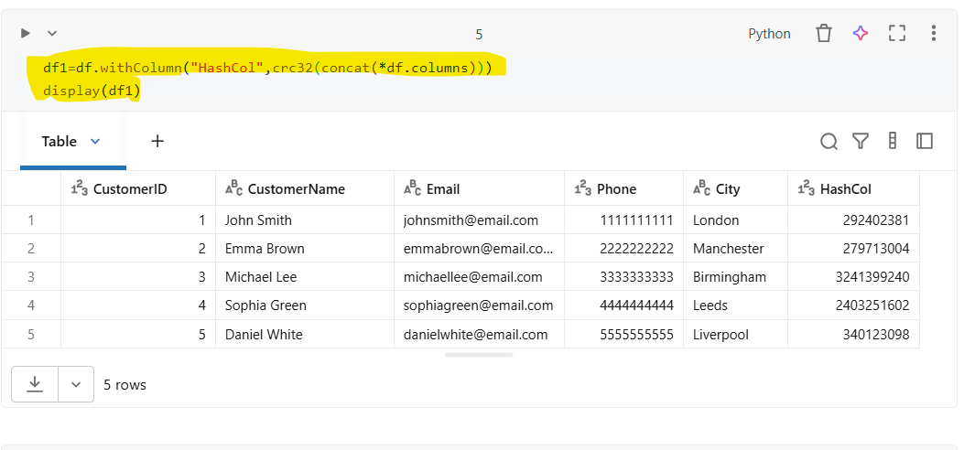
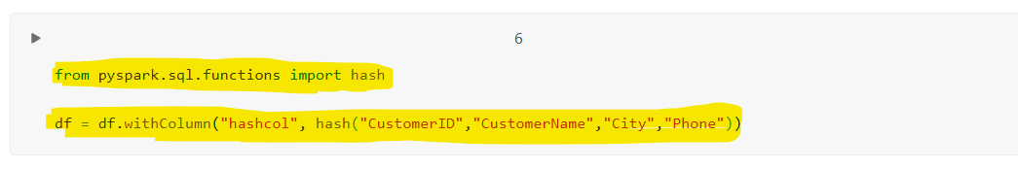

- This any one code creates a new DataFrame by adding a hash column (HashCol) generated from all existing columns.
The hash is used to detect changes in records, commonly in SCD Types implementations

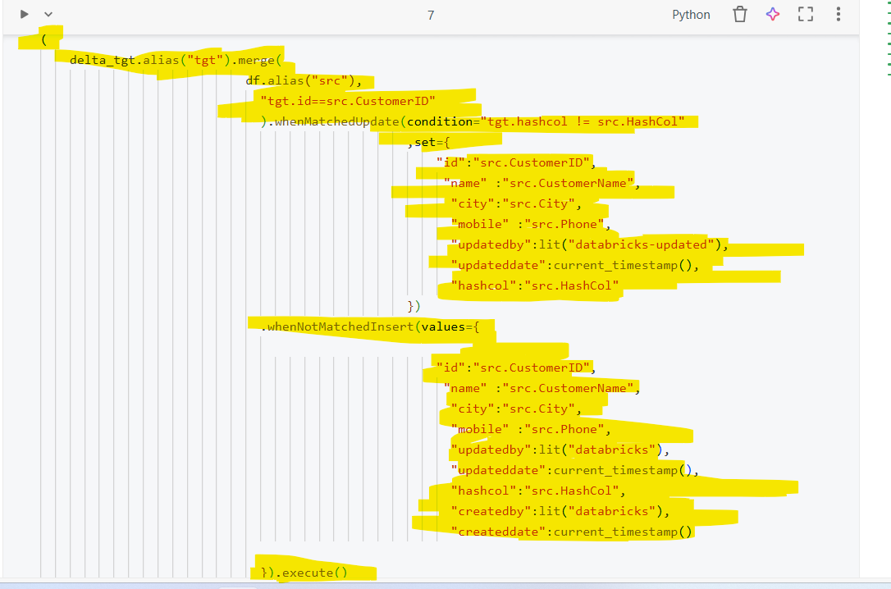

- This code performs a MERGE (UPSERT) operation using Delta Lake to implement SCD Type 1 logic:
- Update existing records when data changes
- Insert new records when they do not exist
- It uses a hash column (hashcol) to detect changes efficiently.

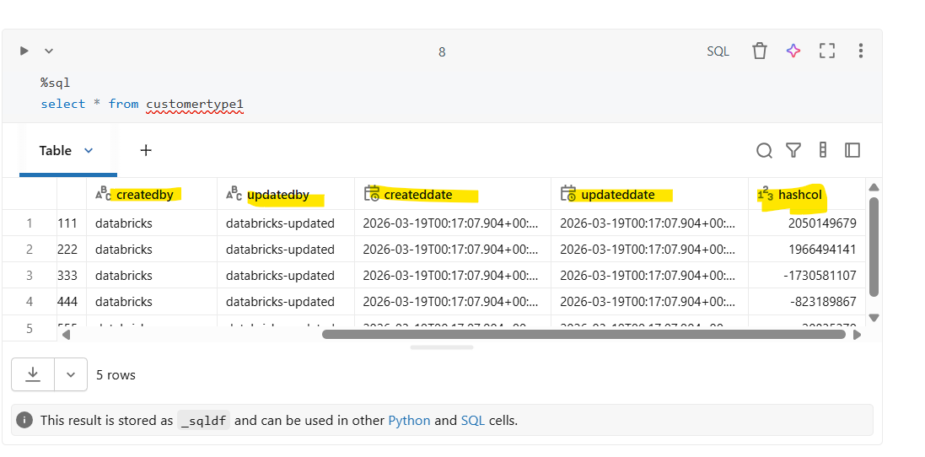

- This code shows the whole table with the updated columns and updated results

